Student Management

Deleting Account

Version <1.0>

Revision History

|  |  |  |  |
| --- | --- | --- | --- |
| **Date** | **Version** | **Description** | **Author** |
| <dd/mmm/yy> | <x.x> | <details> | Đào Anh Thành |
|  |  |  |  |
|  |  |  |  |
|  |  |  |  |

Table of Contents

1. Removing Account 3

1.1 Brief Description 3

2. Flow of Events 3

2.1 Basic Flow 3

2.2 Alternative Flows 3

2.2.1 < First Alternative Flow > 3

2.2.2 < Second Alternative Flow > 3

3. Special Requirements 3

3.1 < First Special Requirement > 3

4. Preconditions 3

4.1 < Precondition One > 3

5. Postconditions 3

5.1 < Postcondition One > 3

6. Extension Points 3

6.1 <Name of Extension Point> 3

Removing account

# Removing Account

## Brief Description

This use case defines the steps of removing an existing account from system.

Administrator can easily remove an account from the system.

## Actor

Admin

# Flow of Events

## Basic Flow

The system administrator selects the computer data to delete. The administrator deletes the computer data from the website. The system displays the updated management parameter value and logs the change.

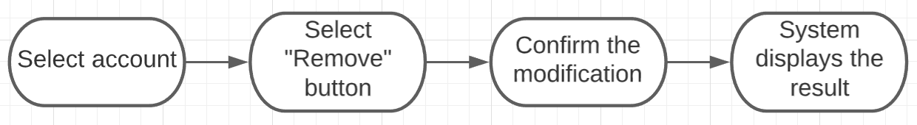

# Special Requirements

There isn’t any

# Preconditions

No preconditions

# Postconditions

No postconditions.

# Extension Points

Admin check the website and the system to ensure that the account is completely removed.